CS 4331 Project 1 Report

Tools used:

AWS SUMERIAN GLTF EXPORTER; It is easy to create a 3d object and export them as a gltf with AWS services.

Glitch: For realtime building

ATOM: For assembling all the test result for glitch and try them with atom server.

Background:

As Covid 19 is spreading widely around the globe. As for project 1 we were given a task to build a virtual reality background which will describe our current situation.

As per my situation I have attached object exported by glitch and added music which I listen to a lot.

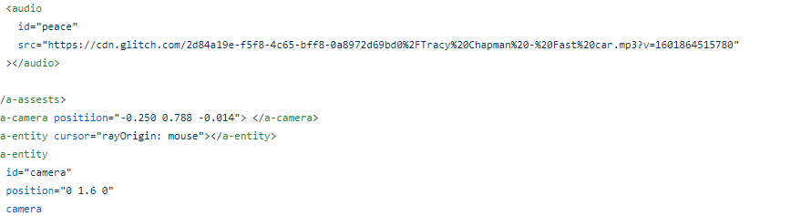

Sound credit: Tracy Chapman (Fast Car)

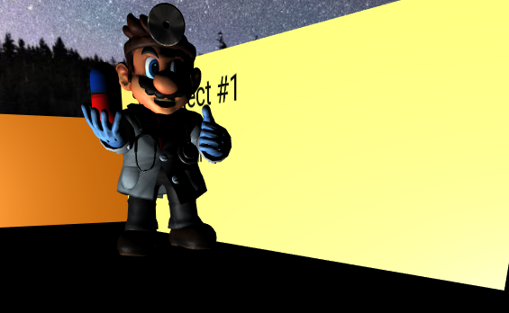

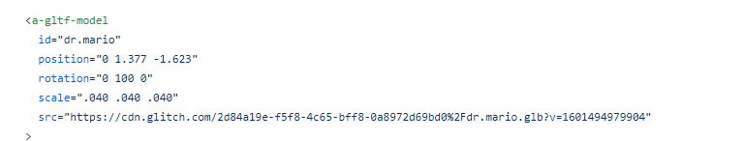

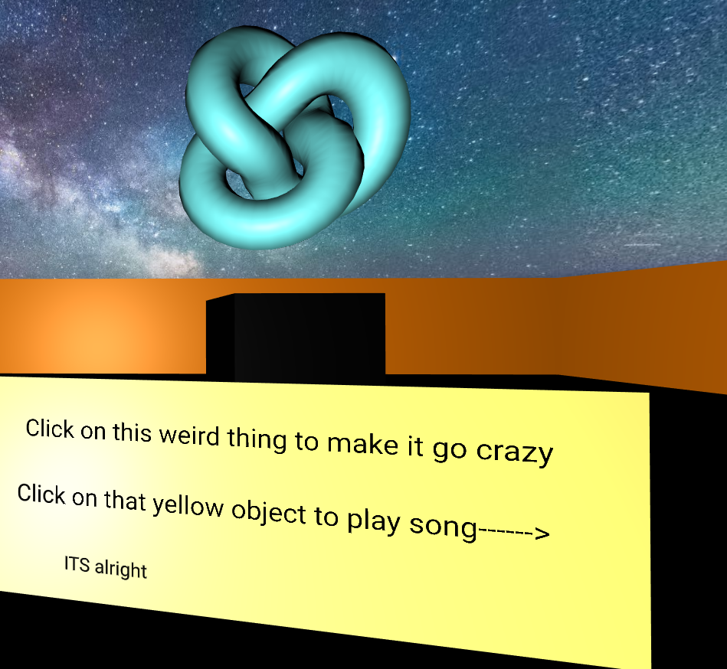

I have added movement like rotation is in this object.

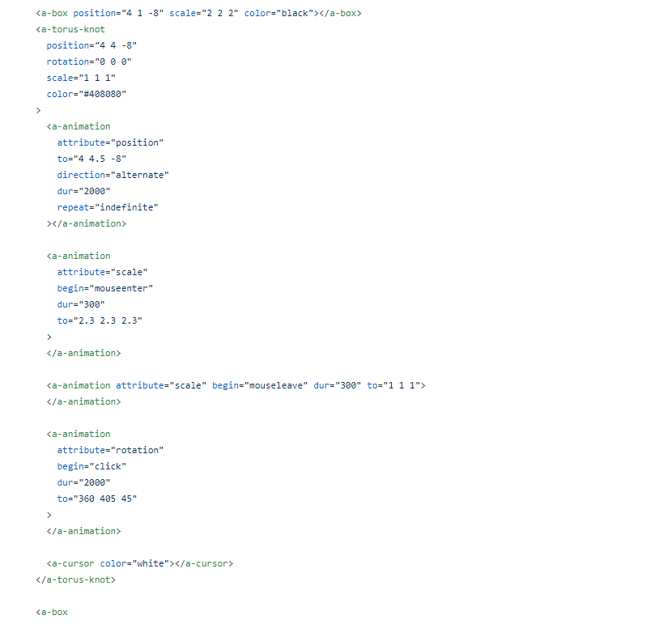



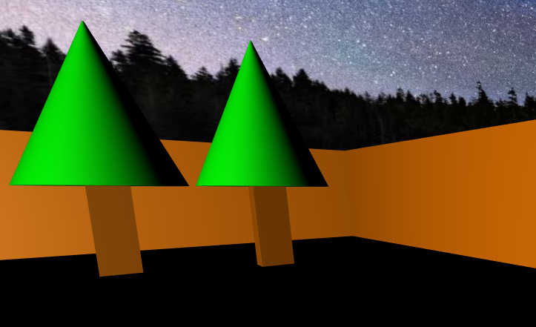

These objects are created using aframe enitities

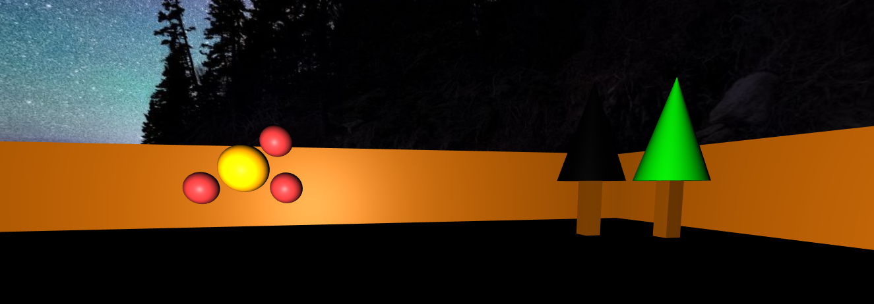

Sound can be played by clicking yellow button and by the time we increase distance from the source the volume of song will start to change.